**AUTOBIOGRAPHY**

**Written by Mary wambui**

**MARY WAMBUI KARIUKI**

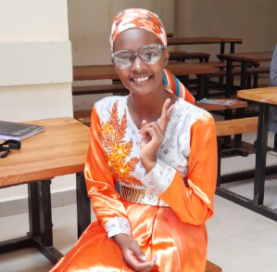

**Early childhood life**

My name is Mary Wambui Kariuki. I am 23yrs old, i was born on 18th August 2000, in Murang’a county at Gakira village. I am a daughter of John Kariuki and Juliah Wanjiru. I am a third born in a family of five.

In our culture , that is kikuyu there is a community support ceremony where almost the entire community comes together to support the new parents with all kinds of gifts such as clothes to the newborn and food, also one week after the child is born the parents take the child to church for prayer blessings so as to keep away spiritual forces from te newborn.

During childhood we used to play various games such as hide and seek, rope skipping, dancing competition,touch and feel the box with other children in the nearby community including relatives.The most interesting memories were in the evening where we could all go to the nearby forest to fetch firewood for preparation of the evening meal. In the early childhood life of the Kikuyu tribe, children are nurtured within the embrace of their extended family, steeped in the rich tapestry of their cultural heritage. Raised amidst the warmth of familial bonds, they learn not only from their parents but also from grandparents, aunts, uncles, and cousins, forming a tightly-knit support network. From a tender age, they are introduced to the sacred traditions and beliefs of their community, absorbing the wisdom of their ancestors through rituals, ceremonies, and oral storytelling. Education, deeply rooted in practicality, unfolds through hands-on experiences, with children apprenticing in essential skills such as farming, cooking, and craftsmanship under the watchful guidance of their elders. As they approach adolescence, initiation rites beckon, marking their passage into adulthood with rituals that instill courage, responsibility, and respect. Within the fabric of Kikuyu society, gender roles delineate tasks and responsibilities, with boys and girls each contributing to the family and community in their distinct ways.

**EDUCATION**

I joined nursery school at the age of 3 years at Gakira nursery school, where we were taught by teacher Naomi , who really helped in nurturing our behavior, showing how to make simple drawings such as shapes and also coloring the shape that we drew. The most interesting moments were during story telling and outdoor playing with other children.

Thereafter I joined lower primary to build on foundational skills that I developed in nursery school

The total number of topics increased from two that were reading and writing to seven which includes science, english, kiswahili,social studies and mathematics. After five years I joined upper primary and on reaching class eight I did my KCPE and passed well.I later joined Ikumbi secondary school for four years,

and at the end of my fourth year I sat for KCSE and I got a B plain which helped me to make an application so as to join Dedan Kimathi University of Technology(DeKut).

I was supposed to join DeKut in the year 2020 for may intake and unfortunately due to corona pandemic, i joined campus on july to pursue bachelor of Science in Business Information Technology and we could study online, the most difficulties that we faced as students during that time was attending online classes, since sometimes we could have poor network connection and one could even not make it to attend the class.

After four months while studying online, issues about the pandemic reduced and we were supposed to report to school in November so as to prepare for the exams. Unfortunately half of the student were able to attend classes while others had challenges and they did not make it to attend classes and therefore we had to work in two groups where we who had been able to study while at home we did our exams and those who had challenges started afresh and they were to do their exams later after four months. Later we stopped working with two groups and the two groups joined and we continued learning like others in the university.

**Social life in campus**

Friendship isthe golden thread that ties the heart of all in the world. In my campus life I learnt alot from friends and we really enjoyed together though walks,hikes and other events like charity work.As students navigate the corridors of learning and self-discovery, the presence of friends serves as a beacon of light, illuminating the path forward and infusing even the most mundane of days with joy and companionship. Together, they weather the storms of academic challenges, offering encouragement, guidance, and a shoulder to lean on during times of uncertainty.Yet, beyond the confines of lecture halls and library stacks, the true essence of friendship blossoms in the shared moments of leisure and adventure. Whether embarking on spontaneous walks through campus grounds, scaling mountain trails on exhilarating hikes, or joining hands in acts of selfless service through charity work, these experiences forge bonds that transcend the ordinary and ignite the spirit of camaraderie.Through laughter-filled heartfelt conversations, friends become pillars of strength, sources of inspiration, and unwavering companions on life's journey. They celebrate victories together, console one another in times of defeat, and offer unwavering support through the ebb and flow of life's tide.

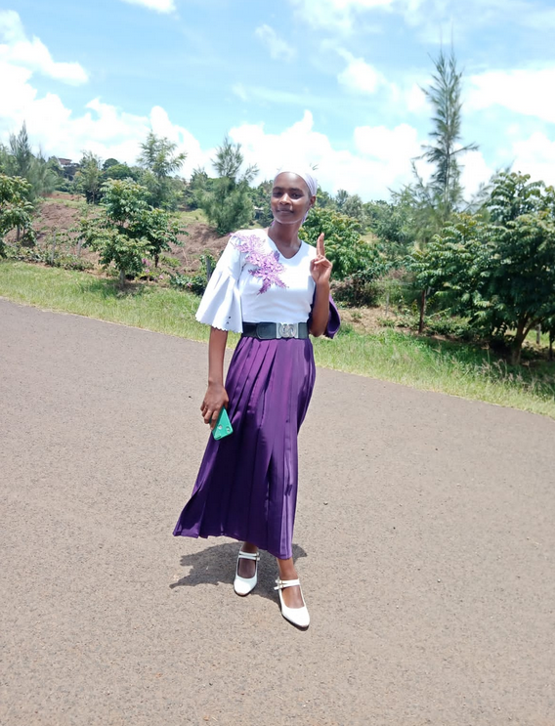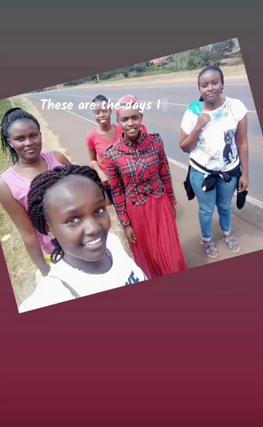

**Joining tech communities**

Dedan kimathi university as a school of technology, during my second year of study, i was able to join tech communities such as data science and artificial intelligence(DSAIC),Google developer student club(GDSC), zindi africa and women tech makers Nyeri, this communities have been organizing many events which help student to understand various technologies and how they are applied in real life, here are photos for various tech events i attended.

These communities serve as platforms for networking, learning, and skill development in the rapidly evolving field of technology. By participating in events organized by these communities, you gained valuable insights into emerging trends, best practices, and practical applications of technologies such as data science and artificial intelligence.Participating in events organized by these communities offers a multifaceted learning experience, allowing you to delve into various technological domains and gain practical insights into their real-world applications. Whether it's through workshops, seminars, hackathons, or networking sessions, these events foster an environment conducive to exploration and discovery, enabling you to stay abreast of the latest trends, tools, and methodologies shaping the tech landscape.

As you immerse yourself in these tech communities, you not only enhance your technical proficiency but also cultivate essential soft skills such as teamwork, communication, and problem-solving. Collaborating with fellow students and industry experts on projects and initiatives not only broadens your perspectives but also fosters a sense of camaraderie and shared purpose within the tech ecosystem.

The photos from various tech events you attended serve as tangible reminders of your active involvement and meaningful contributions to the tech community. They encapsulate moments of learning, inspiration, and camaraderie, showcasing your dedication to personal and professional growth in the field of technology.

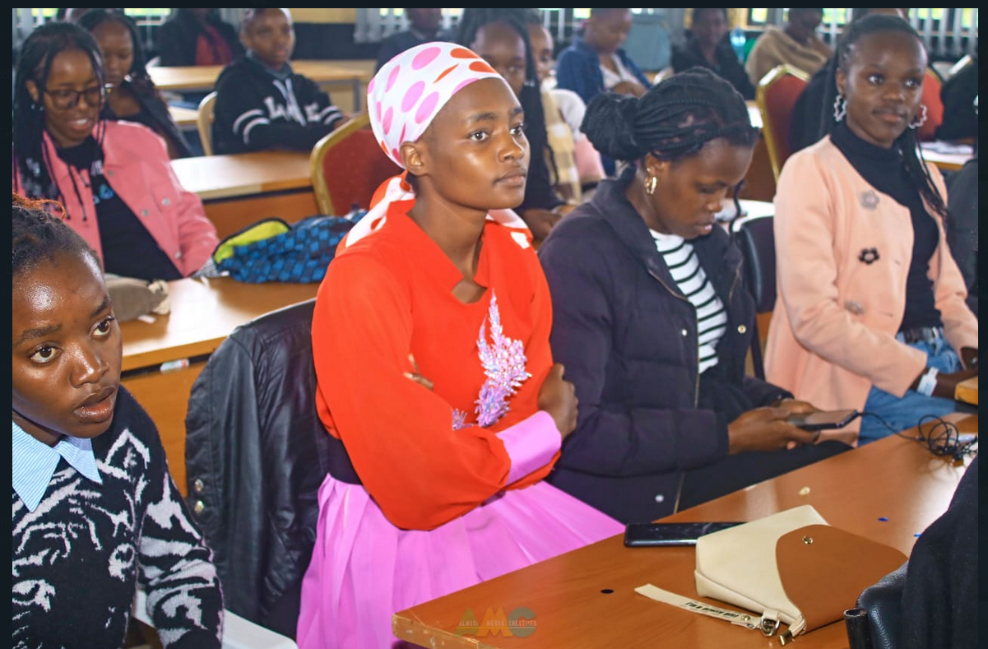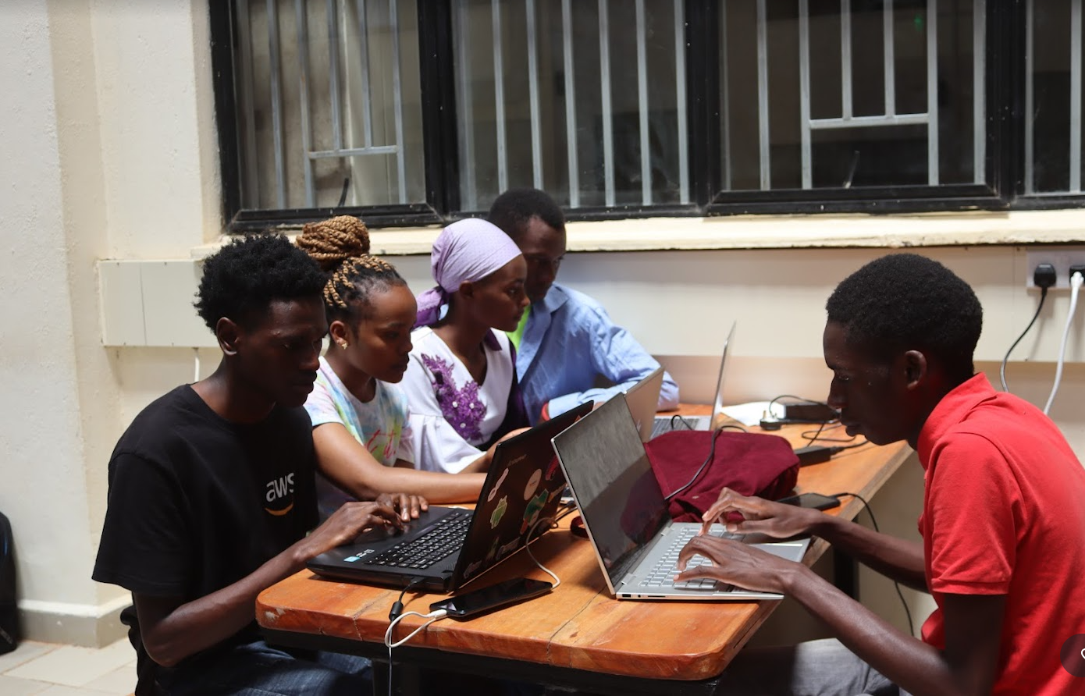

Personally, I was exposed to various technologies and I got interested in various fields such as data science, machine learning and deep learning. I decided to join the DSAIC community as it was one of the communities which was dealing with data science and machine learning, where I was taught and guided about machine learning. During my third year of study , I had the opportunity to be part of the DSAIC executive committee and I was elected as the vice president.

**Community lead at Data Science and Artificial Intelligence club (DSAIC)**

I joined the data science and artificial intelligence club as a community lead and I did my best as the vice president of the club to make the club better than I found it. DSAIC is a club that helps students in understanding machine learning concepts and hosts events that help students to be exposed to technologies in the industry. Dsaic hosts weekly learning sessions on every tuesdays , where the community leads they help in teaching and guiding students during weekly sessions. Personally I used to help guide students on feature engineering and scikit-learn in machine learning.The weekly learning sessions held every Tuesday provide a structured forum for students to engage with key concepts and techniques in machine learning. As a community lead, your role in guiding and instructing students during these sessions is invaluable. Your expertise in feature engineering and scikit-learn not only enhances the learning experience but also empowers students to tackle real-world challenges with confidence and proficiency.By leveraging your knowledge and experience, you help demystify complex concepts and provide practical insights into the application of machine learning algorithms. Your guidance enables students to navigate the intricacies of feature engineering and leverage the capabilities of scikit-learn to develop robust and effective machine learning models.

Beyond technical instruction, your leadership within DSAIC fosters a sense of camaraderie and collaboration among members, encouraging peer-to-peer learning and knowledge sharing. Through your mentorship and support, students are empowered to explore their interests, push the boundaries of their understanding, and ultimately, chart their own paths to success in the field of data science and artificial intelligence.

In essence, your contributions as a Community Lead and Vice President of DSAIC not only elevate the club's offerings but also leave a lasting impact on the personal and professional development of your fellow students. Your dedication to excellence and your passion for empowering others exemplify the spirit of leadership and innovation that defines the DSAIC community.

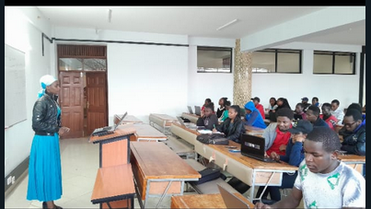

**Community work**

As good leaders I took part in helping the club grow at greater heights and we looked forward to partnering with ABSA bank and DSAIL , to help the DSAIC club to extend beyond the university so as to reach other data enthusiasts outside the school so that there could be collaboration even with other industries. DSAIL which is an organization in DeKut partnered with the club and I was lucky to get an attachment opportunity as junior machine learning engineer where I worked closely with the interns in the organization and also they helped in sponsoring events. ABSA bank also help in sponsoring events hosted by the club such as hackathon,tech talks among others The partnership with ABSA bank presents an exciting opportunity to secure sponsorships for events hosted by DSAIC, including hackathons, tech talks, and other initiatives. These sponsorships not only provide financial support but also facilitate networking opportunities and exposure to industry professionals, enriching the learning experience for club members and fostering connections between academia and industry.

Similarly, the collaboration with DSAIL, an organization within DeKUT, opens doors to valuable attachment opportunities for club members, including yourself. As a junior machine learning engineer, you had the chance to gain hands-on experience and work closely with interns in the organization, further honing your skills and deepening your understanding of real-world applications of data science and artificial intelligence.Moreover, the partnership with DSAIL goes beyond attachment opportunities, as they also contribute to sponsoring club events, demonstrating a shared commitment to nurturing talent and fostering innovation within the tech community. Through these collaborations, DSAIC not only extends its influence beyond the university but also establishes itself as a key player in the broader data science ecosystem, facilitating knowledge exchange and collaboration with other industries and organizations.

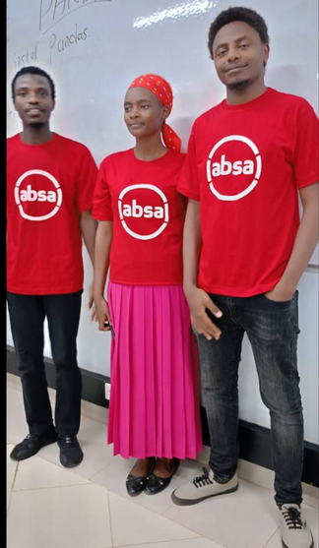

As a custom in the DSAIC club, I took part in organizing a hackathon , which is always held at mid-year and also at the end of the year., where every executive member was given a responsibility to make the event happen such as calling for speakers, looking for a venue,, reminding our partners that we require sponsorship, order meals to cater for attendees, and create a platform where the student will participate during competition. I was assigned a responsibility to call for speakers and also print t-shirts for the executive committee.

We had several speakers among them being the founder of the club who is currently working as a data analyst Mr.oyori obegi, also we invited harun mbaabu who is a data engineer and nancy kabura who is a machine learning engineer. Here are the photos that show how teamwork leads to success, that is teamwork among leaders made the event successful.

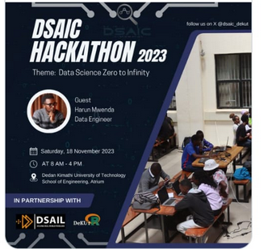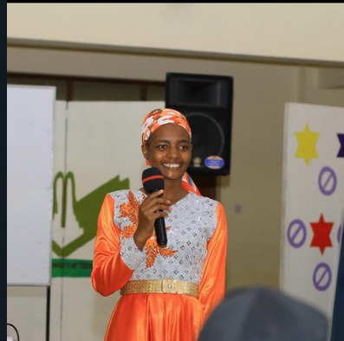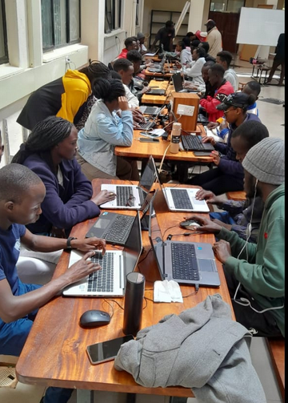

After the end of the competition i had chance as the outgoing vice president to present rewards to the winning teams, where they were given a certificate of merit and a merchandise

As per DSAIC constitution one is supposed to be a community lead for a period of one year, therefore during the end of year DSAIC hackathon , my term was coming to the end with the rest of the team members and we had to hand-over the leadership position to the new team.

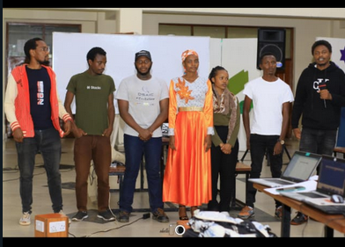

I was issued with a certificate of recognition as an outgoing vice president for the good work done.

**Personal achievements**

***AI research assistant(DSAIL)***

I got an opportunity as an AI research assistant at DSAIL which is a center for data science and artificial intelligence at DeKut, which has helped me to upskill. Back last year, i had a chance to participate in DSAIL research day, which is held annually to appreciate the members in the organization and showcase their achievements.Participating in DSAIL's research day, held annually to celebrate the achievements of members within the organization, is a significant milestone in your journey as an AI research assistant. This event serves as a platform for showcasing the groundbreaking research conducted by DSAIL members, highlighting their contributions to the field and fostering collaboration and knowledge sharing among peers.

As a participant in DSAIL's research day, you have the opportunity to present your own research findings, share insights gained from your work as an AI research assistant, and engage with fellow members and industry professionals. This experience not only provides valuable exposure and recognition for your contributions but also allows you to receive feedback, exchange ideas, and expand your network within the research community.Moreover, DSAIL's research day reinforces the culture of excellence and innovation that defines the organization, inspiring members to push the boundaries of knowledge and pursue groundbreaking research initiatives. By participating in this event, you contribute to the collective success and reputation of DSAIL, further solidifying its position as a leading hub for data science and artificial intelligence research and development.

During this day everyone was supposed to showcase the project he/she was working on, personally i was working on a project which was about maize yield forecasting in mitigating food insecurity. This research was based on how unpredictable weather patterns is affecting planting and sowing seasons leading to food insecurity

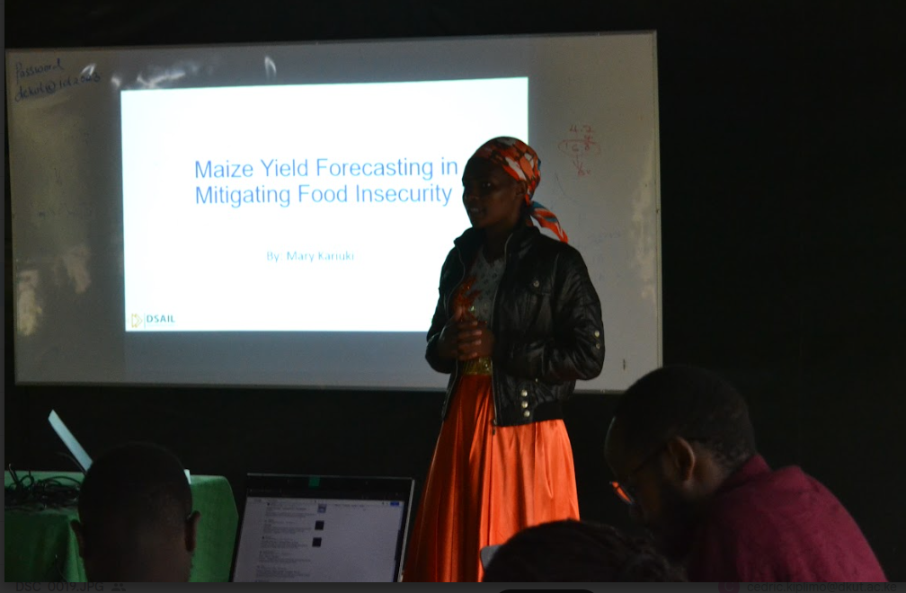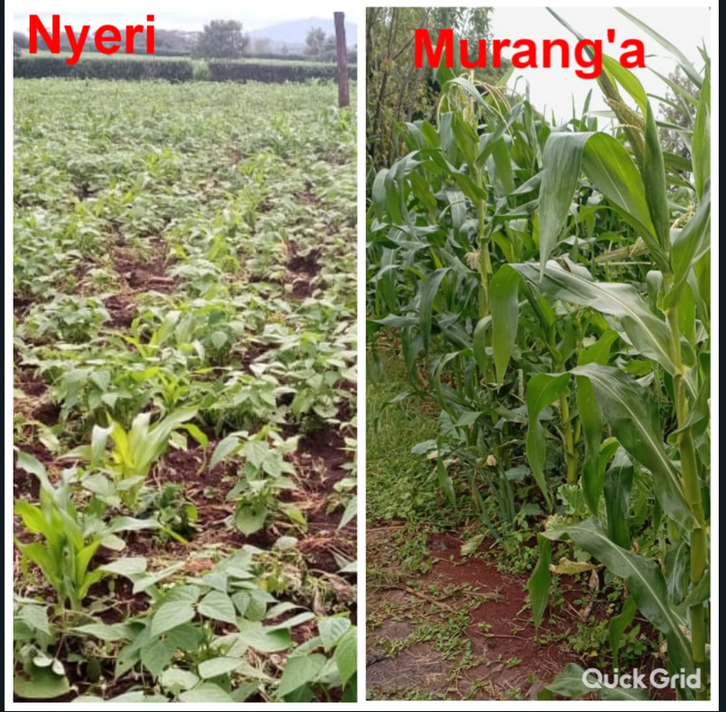

Afterwards, we had time to network and celebrate good work done by everyone through cake cutting and taking the group photo.

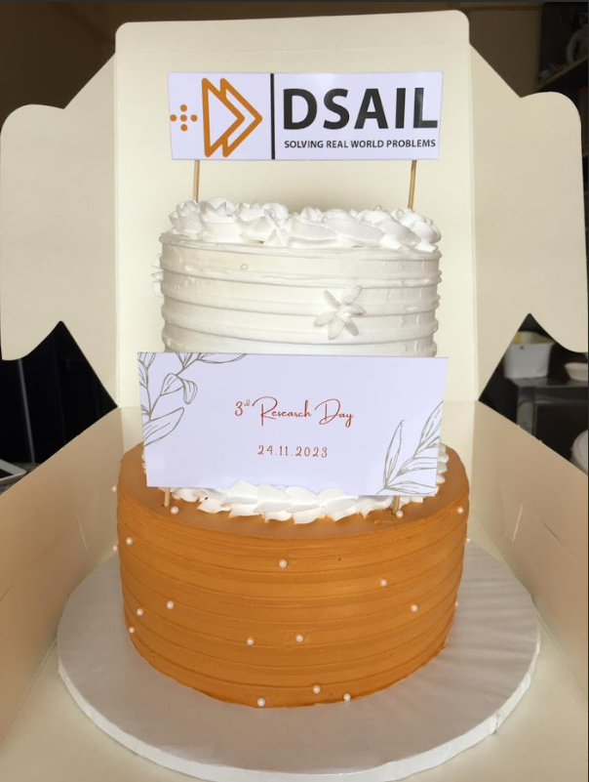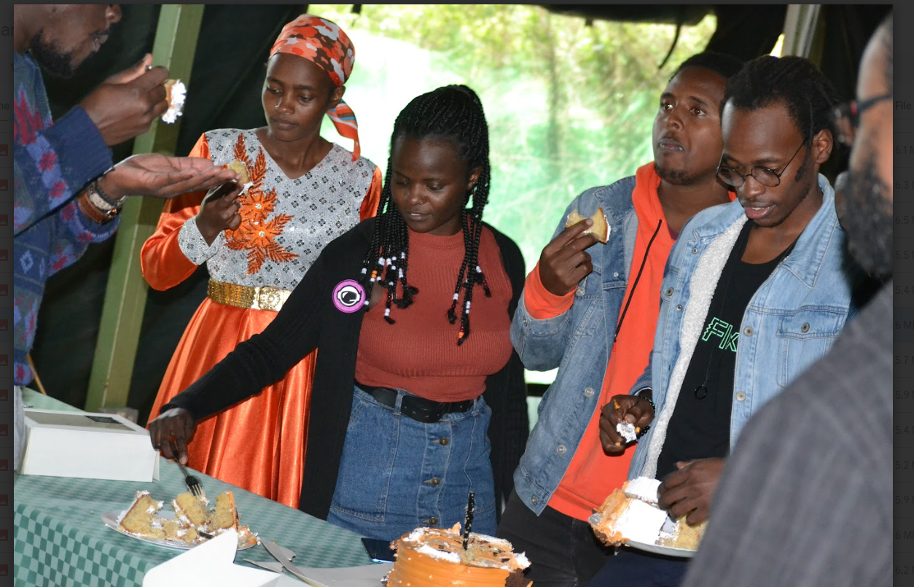

***Data annotator at CVAT.AI***

Recently i got an opportunity as a data annotation specialist at a company named under annotation tool that is CVAT.AI working remotely, where my responsibility is to annotate videos and images for deep learning projects, here are several that i have annotated. This is a skill I learnt during the attachment period where I used to annotate images for certain intern so that she can get data to do her project lung cancer prediction. Working remotely in this capacity provides you with a unique opportunity to contribute to deep learning projects by annotating videos and images, thus playing a crucial role in training machine learning models to recognize patterns and make predictions.

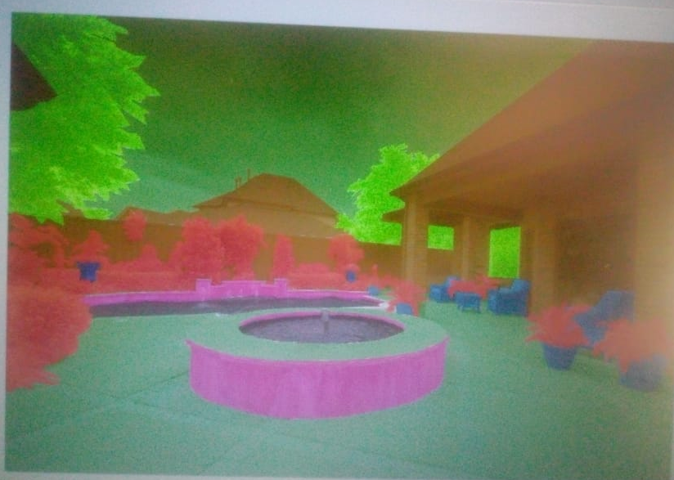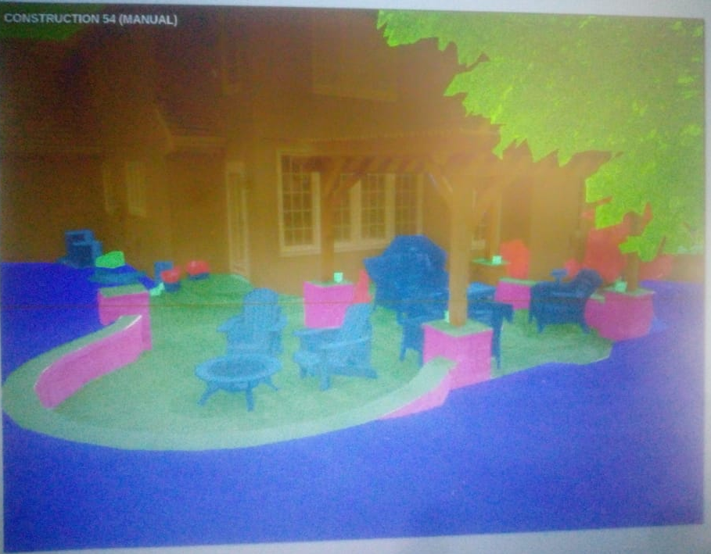

***Technical writer at Write the Docs Kenya(WTD)***

I am currently working with the content creator team at Write the Docs Kenya, where my responsibility with several of the team members is to write technical documents and publish at WTD website, this has helped me in understanding more in my area of interest that is machine learning and deep learning. WTD is a community that helps technical writers in sharing their knowledge, collaborating and also networking. The community will be hosting its first physical event in May at KCA university where i am an attendee and I feel it's the best way to network with other techies and know more about the new technology.Being part of the Write the Docs community not only enhances your technical writing skills but also provides you with opportunities for collaboration and networking within the technical writing community. By engaging with fellow writers, sharing experiences, and learning from each other's perspectives, you gain a deeper understanding of best practices in technical communication and broaden your professional network.The upcoming physical event hosted by Write the Docs Kenya at KCA University represents an exciting opportunity for you to further immerse yourself in the technical writing community and expand your knowledge horizon. As an attendee, you'll have the chance to interact with like-minded individuals, exchange ideas, and learn about the latest trends and developments in the field of technical writing.Attending the event enables you to network with other tech enthusiasts, including professionals and industry experts, who may share insights and experiences relevant to your interests in machine learning and deep learning. Building connections within the tech community can open doors to new opportunities, collaborations, and potential mentorship relationships that can further accelerate your career growth and learning journey.

**Hobbies and interest**

My hobbies include

* Traveling
* Singing
* Cooking
* Community work
* Ride biking

Through the chapters of my life, I've come to understand the great impact of gratitude, purpose, and passion. I am endlessly grateful for the unwavering support and love of my family, the guidance of mentors, and the kindness of friends who have walked alongside me on this journey. Their belief in me has helped me in focusing my determination and enriched my experiences. As I reflect on my path, I've discovered that true fulfillment lies in living with purpose and pursuing my passions wholeheartedly. endlessly grateful for the unwavering support and love of my family, the guidance of mentors, and the kindness of friends who have walked alongside me on this journey. Their belief in me has helped me in focusing my determination and enriched my experiences. As I reflect on my path, I've discovered that true fulfillment lies in living with purpose and pursuing my passions wholeheartedly. The belief and encouragement of your loved ones and mentors have played a pivotal role in empowering you to navigate challenges and pursue your aspirations with determination and focus. Their unwavering support has provided a strong foundation upon which you can build and grow, instilling in you the confidence to overcome obstacles and embrace new opportunities.As you reflect on my journey, you recognize the transformative power of purpose and passion in shaping your experiences and driving your actions. Living with purpose imbues your life with meaning and direction, guiding you towards goals that resonate with your values and aspirations. It compels you to align your actions with your beliefs, fostering a sense of fulfillment and satisfaction in the pursuit of meaningful endeavors.embracing my passions wholeheartedly ignites a fire within you, fueling my creativity, drive, and enthusiasm. When you channel your energy into activities that ignite your soul, you unlock your full potential and experience a profound sense of joy and fulfillment. My passion becomes a driving force, propelling you forward in my journey and infusing every moment with purpose and meaning.

In essence, my journey is a testament to the transformative power of gratitude, purpose, and passion. By cultivating gratitude for the blessings in your life, embracing purpose as a guiding principle, and pursuing your passions with unwavering dedication, you have unlocked the key to a life rich in fulfillment, growth, and meaning. As you continue to traverse the chapters of my life, may you continue to embrace these principles, knowing that they will guide you towards greater fulfillment